OPERATION TAKE BACK NJ

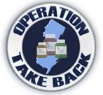

On Saturday, October 26, 2013, between the hours of 10 a.m. and 2 p.m., the Bloomingdale Police Department will be participating in “Operation Take Back NJ”. This program which is sponsored by the Drug Enforcement Administration Division, is to provide a safe way for disposing of unused, unwanted or outdated prescription medications. All are invited to drop off their medications at the Bloomingdale Police Department which is located at 101 Hamburg Turnpike, Bloomingdale. It is suggested that all personal information on labels be removed.

Any questions can be directed to the Bloomingdale Police Department at 973-838-0158.

Chief Joseph Borell
Bloomingdale Police Department

