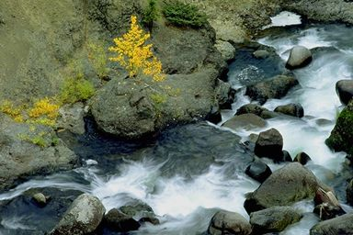

RIVER CLEANUP – SATURDAY, AUGUST 24, 2013

MEET AT SLOAN PARK 10 A.M.

