OLDER AMERICANS MONTH
PROCLAMATION OF THE BOROUGH OF BLOOMINGDALE
-May 2024-
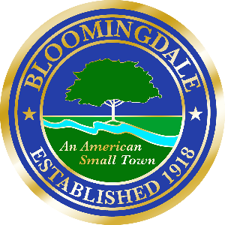

WHEREAS, The Borough of Bloomingdale includes a growing number of older Americans who contribute their time, wisdom, and experience to our community; and
WHEREAS, communities benefit when people of all ages, abilities and backgrounds have the opportunity to participate and live independently; and
WHEREAS, the Borough of Bloomingdale recognizes our need to create a community that provides the services and supports older adults may need to make choices about they age; and
WHEREAS, the Borough of Bloomingdale can work to build and even better community for our older residents by:
Not limiting our thinking about again,
Exploring and combating stereotypes,
Emphasizing the many positive aspects of aging,
Inspiring older adults to push past traditional boundaries, and
Embracing our community’s diversity
NOW THEREFORE BE IT PROCLAIMED, we the council of the Borough of Bloomingdale do hereby proclaim, May of 2024 to be Older Americans Month. We urge every resident to celebrate our older citizens, help to create an inclusive society and accept the challenge of flexible thinking about aging.

Dated this 7th day of May, 2024
John D’Amato, Mayor

